CALIFORNIA STATE ASSOCIATION
presents
Three Parliamentarians
It cannot be denied that reasonable minds will, and do, differ.

MASON Played by Jim Stewart, PRP Immediate Past President, CSAP
STURGIS Played by Esther Heller, PRP Past President, CSAP
ROBERT Played by Gerry Olsen, PRP-R Past President, CSAP
A Case Study
The PASC is a non-profit organization who primary purpose is educational. The Assembly includes 100 voting members. The Assembly meets to conduct business once per year. Assembly bylaws authorize the Board of Directors to “transact the business of PASC between the Annual Meeting and perform duties set forth in the Board Rules of Procedure.” The Board may “adopt Board Rules of Procedure not in conflict with these bylaws or [] action taken by the Annual Meeting.”

PASC bylaws further provide that, “The Board of Directors shall create such special committees as may be required to transact the business of PASC.” The Assembly elected new officers 10 weeks ago. At a meeting of the Board one week later, the PASC Annual Meeting Planning Committee (AMPC) was created.

At a Board meeting one month later, the Annual Meeting budget recommended by the AMPC was approved by the Board, and the AMPC given full authority to act in situations directly related to the planning and execution of the Annual Meeting.

DISCUSS
- Must the budget approved by the Board, and the authority delegated by the Board to AMPC, be ratified by the Assembly at the next AM?
- Are promises made by the AMPC based on delegated authority binding on the Assembly?
Let the discussion begin!

Speaker Speech
ROBERT  Sturgis  Mason  ROBERT  Sturgis  Mason  ROBERT  Mason  ROBERT  Sturgis  Mason  ROBERT  Sturgis  Mason  ROBERT | Esteemed colleagues, the question must be: did the actions taken consider the rights of the majority, of the minority, of individual members, absentees, and all of these together?  What special ruled of order, if any, apply? Are the Board Rules of Procedure special rules?  The General knows that boards have limited powers to delegate; the real power is with the assembly, which may object to actions of the Board and by extension the AMPC.  My dear colleagues, being a legislative parliamentarian I am unaccustomed to ordinary societies, but I am quite familiar with the idea of referred powers, I’m sure we can agree the board is subordinate to and answers to the assembly. In this case assembly has referred its powers to the board to “transact the business of PASC” between Annual Meetings.  And the question is, were these actions of the board valid when taken?  Respected parliamentarians, may not the board’s actions relate to unfinished business of the assembly? Did these actions dispose of a question that came over from a previous meeting without plans for an adjourned meeting, and within a quarterly time interval?  My dear General, what of the bylaws? They control any matter addressed, are we agreed? As such, did the board's creation of and delegation to the AMPC surpass the authority created and delegated to it by the assembly itself in approving the bylaws?  My dear colleagues, the bylaw passages in question seem quite impossible to quote out of context. The necessary precision is found in the language, thus rendering its meaning clear and unambiguous – the board has the power and authority to conduct business of PASC between Annual Meetings.  Esteemed colleagues, all deference due, on the related question of who is bound by promises made by the AMPC and pursuant to its delegated authority, I say this; that whether or not the delegation itself would survive a point of order, responsibility remains with those doing the delegating, in this case, with the board.  Most Noble Mason, but is it really the board? How much weight is given to language in the bylaws already approved by Association members?  Most Honorable General, though the bylaws authorize the board to “transact the business of” PASC “between the Annual Meeting” is not the board in turn authorized to create and fully empower an AMPC answerable to the board? Surely you agree that a board has power to appoint sub-committees even without express authority in the bylaws.  Yes, Dear Mr Mason, a board can appoint sub-committees of its own members directly accountable to the full board.  Returning to the original question, common sense would say that ratifying an action, in this case forming the subcommittee, of a Board at the very event which said committee had organized is rather like closing the barn doors after the horses have escaped. It is not a practical use of the assembly's time.  There is nothing so rare as common sense.  Esteemed Parliamentarians, can we agree that whatever else might apply, any action of a governing board can be rescinded or modified by the Assembly? Ratification is not a singular option.  In the final analysis, bylaws have direct bearing on the rights of members within the organization. One seeking full participation in an organization should become familiar with its bylaws.  The power to control amendments to the bylaws is exclusive to the full assembly.  Except as the rules may provide otherwise, the assembly has full and sole power to act for the entire organization and does so by majority vote.  The rights of each member, to the extent they are definite, are protected by law. However, they must be regarded in relation to the rights of other members and to the organization.  FINI!

A Zoom Poll asked:

- Must the budget approved by the Board, and the authority delegated by the Board to AMPC, be ratified by the Assembly at the next AM?

- Are promises made by the AMPC based on delegated authority binding on the Assembly?

And the results are:

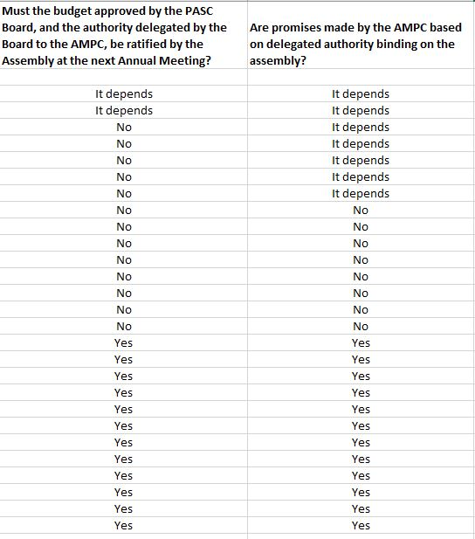

The Board has 10 members, 5 members elected for two-year terms by the Assembly in even-numbered years, the other 5 members appointed by the President for one-year terms with Executive Committee approval.

