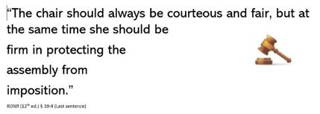 Presiding Means Deciding

Members decide whether to attend meetings. Some whether to speak during meetings. Some decide whether or not to become familiar with club rules and procedures. Some members wait to hear news from others who attend the meetings. Some members read newsletters, and some don’t. Some members do some of these things all of the time and some some of the time and some never read club news or rules, rarely attend meetings and don’t speak when they do. Some members accept leadership roles like president, committee chairmanship, director, secretary, coordinator, and the like, and most do not. If you are president of your wee group, you are probably a “presiding officer”.

Robert’s Rules of Order Newly Revised, aka RONR 12th ed., tells us at § 47:13 that sometimes, the “chairmanship of an invited non-member who is skilled in presiding” could be a good idea under some circumstances. Mostly, presiding officers are not vastly experienced in presiding, and § 47:17 – “Suggestions for inexperienced presiding officers” is more to the point. In that section RONR warns, “The larger the assembly, the more readily it will detect the slightest weakness in a presiding officer. [] sometimes with disastrous results.” Oh my!

Are you (like many of us) nervous about presiding? Do you want to allay those fears? You’ve taken a great step in that direction! CSAP’s current website theme is Presiding Means Deciding. A presiding officer of any assembly – a committee of 3 or an assembly of 300 – must preside and decide if the best use of time and energy will be achieved.

Do you want to develop or sharpen your presiding skills? Start with a visit to the Welcome Tile on this website and test yourself with CSAP’s Quick Quiz on Presiding. Then, click on the “RONR Short Takes” drop down menu for a brief parliamentary lesson on Presiding Means Deciding. And finally, prepare to preside by becoming a CSAP member, where learning to master applied parliamentary procedure is the order of the day every day!

And Thank You for visiting our website! Come back soon!

QUICK QUIZ by Dave M based on RONR In Brief.
RONR Short Take “Presiding Means Deciding” by Sally L based on RONR.

